**Lab7 Spark**

* First I have downloaded the spark
* Unzipped and setuped the environment variables.

cd /home/hadoop/spark

cp ./conf/spark-env.sh.template ./conf/spark-env.sh

* Append a line to the file: spark-env.sh:

export SPARK_DIST_CLASSPATH=$(/home/hadoop/hadoop-3.2.4/bin/hadoop classpath)

* In shell, run the command:

cd /home/hadoop/spark

bin/run-example SparkPi

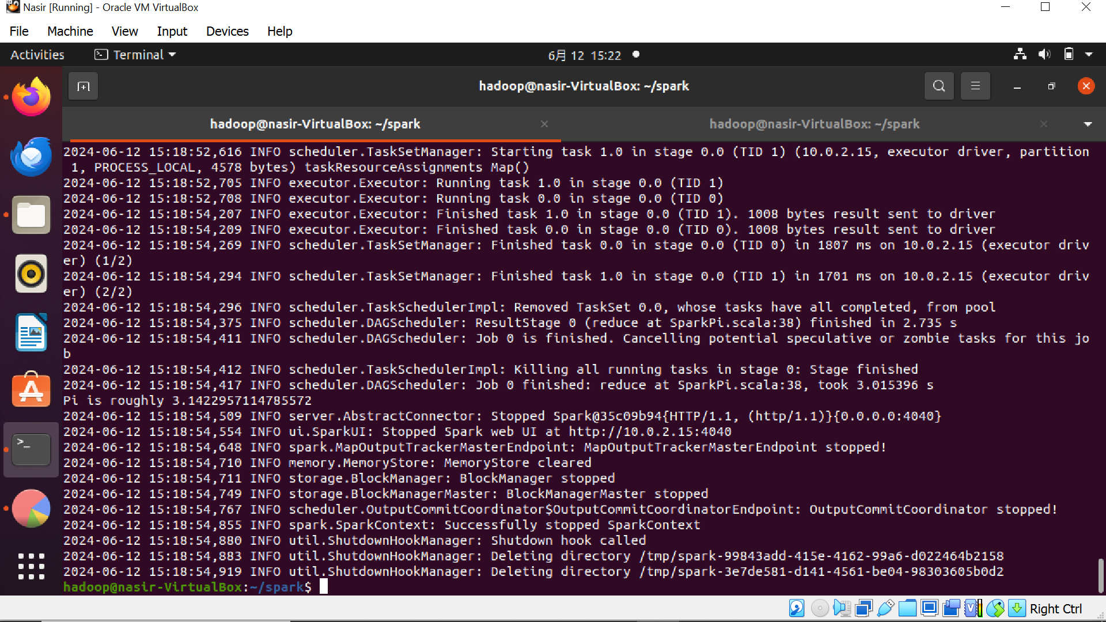

* Then I Create and edit wordcount.py in /home/hadoop/
* Then In shell, run :

cd /home/hadoop/spark

./bin/spark-submit /home/hadoop/wordcount.py

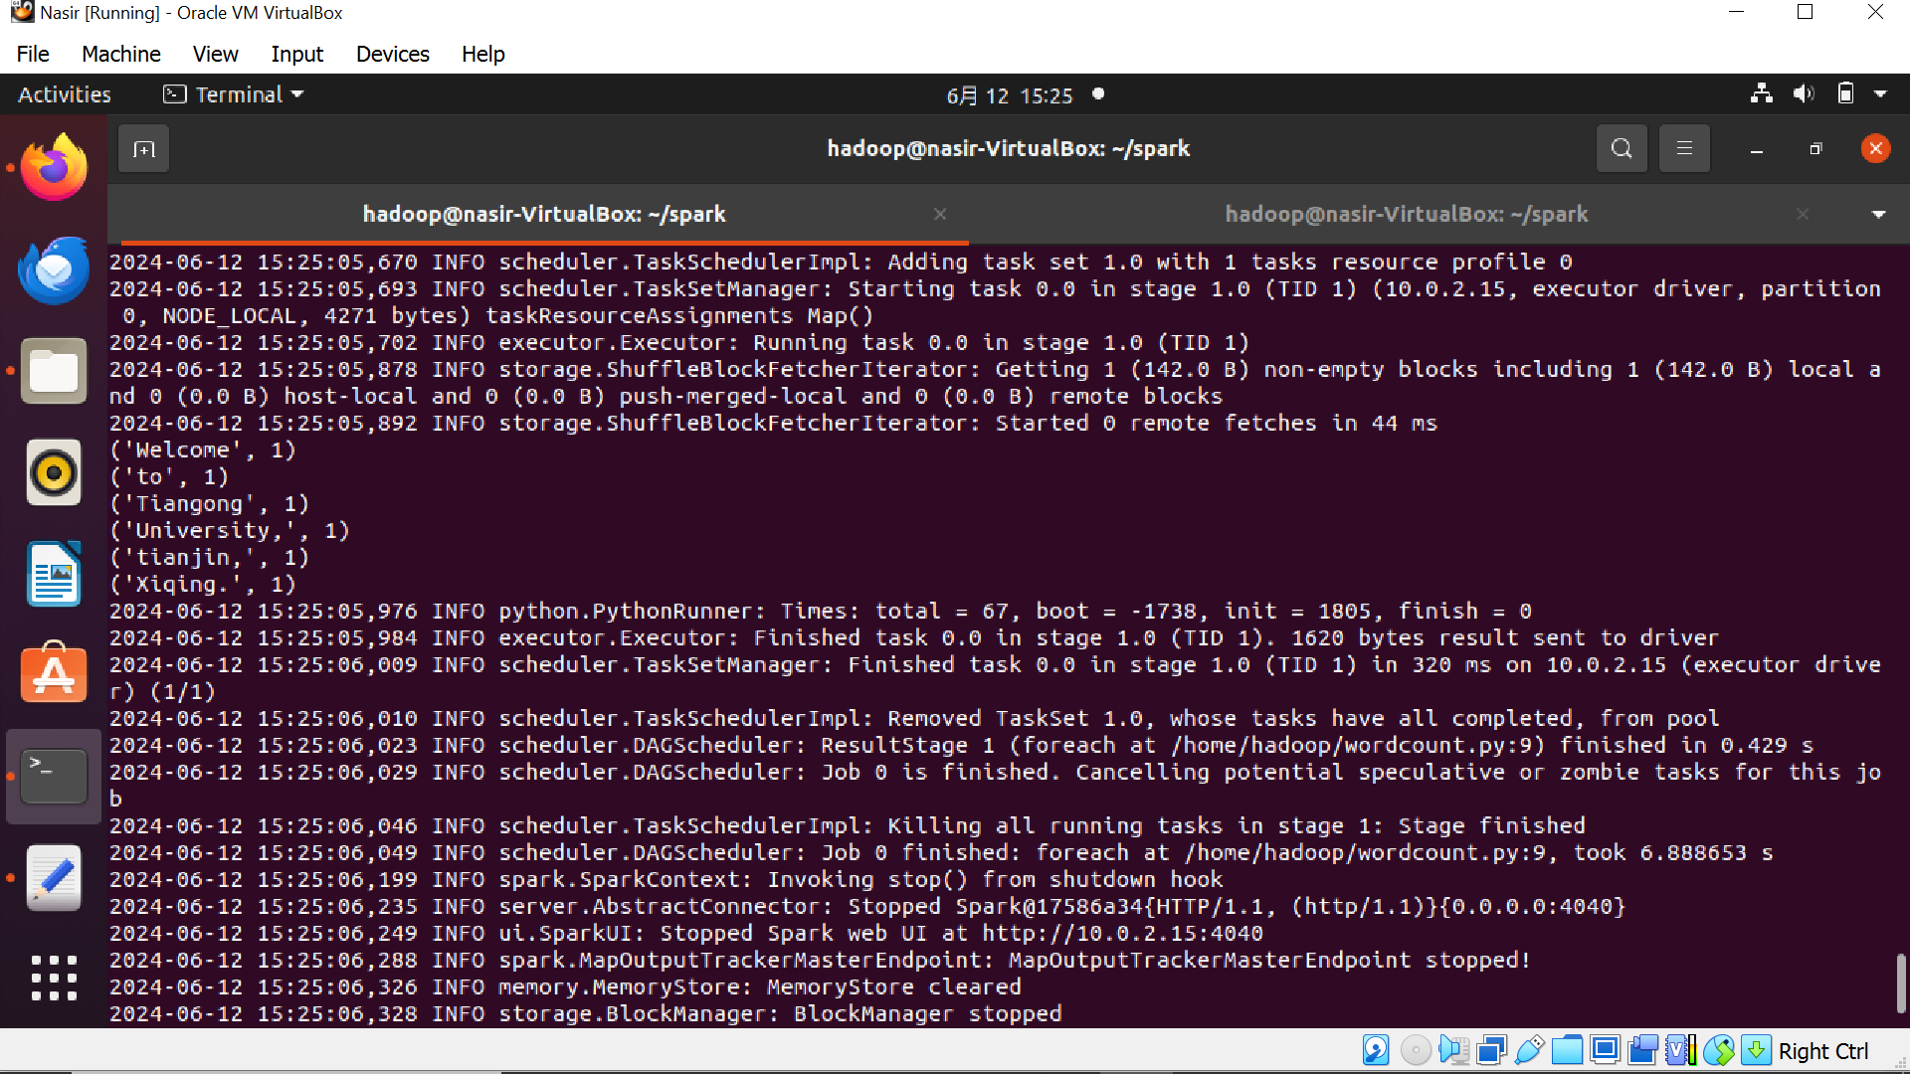

**Task1**

lines = sc.textFile("file:///usr/local/spark/sparksqldata/Data01.txt")

res = lines.map(lambda x: x.split(",")).map(lambda x: x[0])

distinct_res = res.distinct() # Remove duplicates

distinct_res.count() # Get the total number of elements

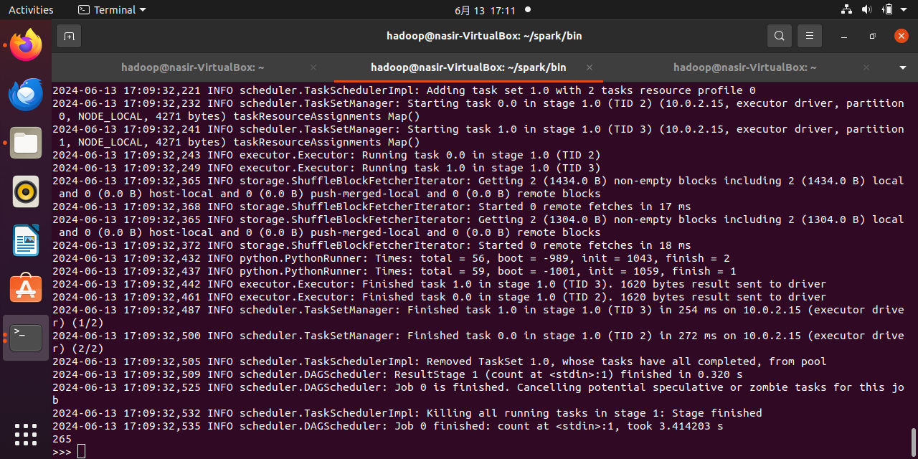

**How many courses are offered in the department?**

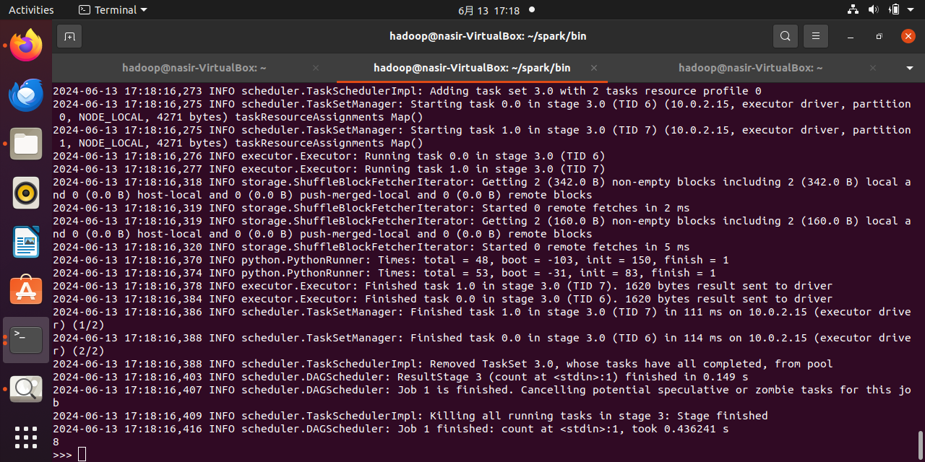

**What is the average total score of Tom?**

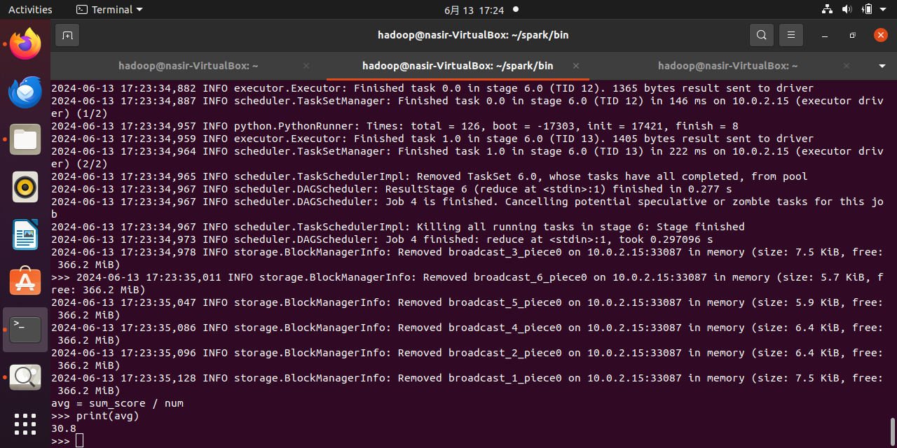

**How many courses has each student taken?**

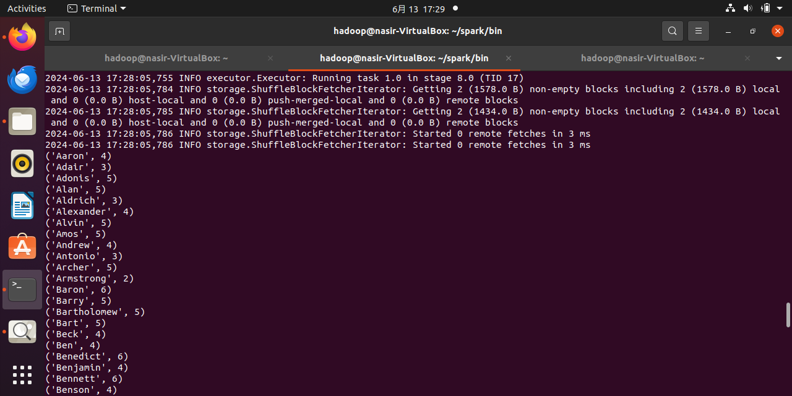

**How many students have enrolled in the DataBase course?**

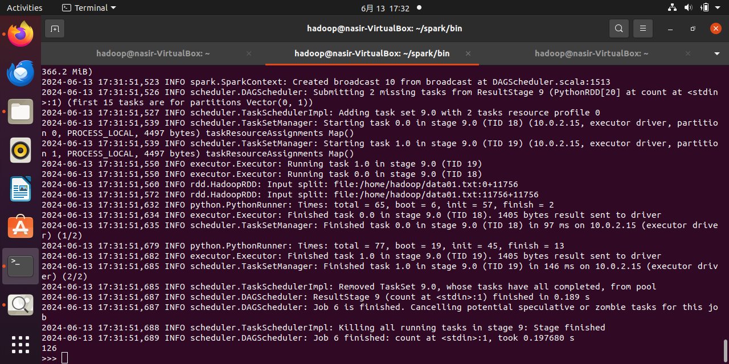

**What is the average score for each course?**

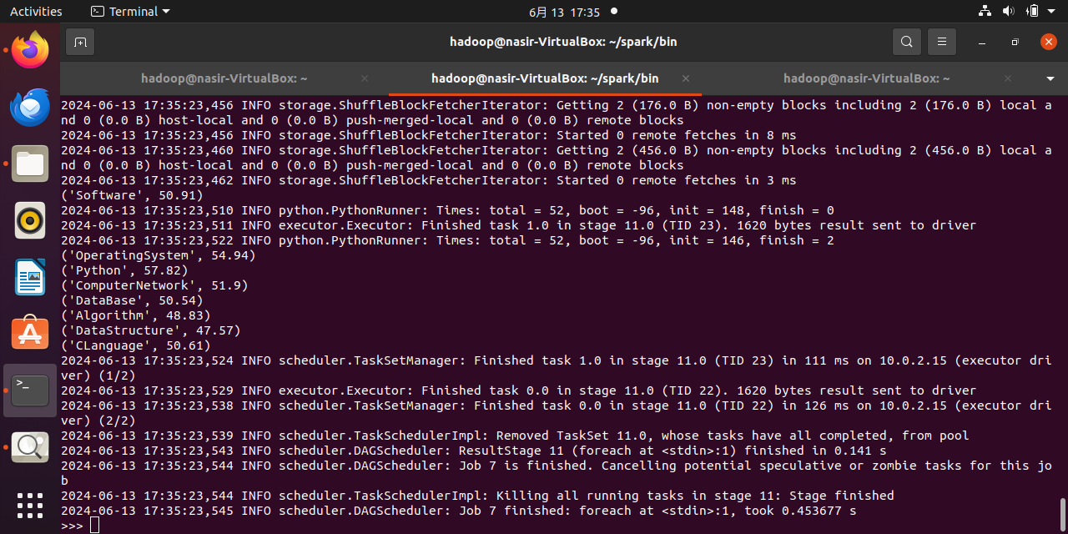

**Use an accumulator to calculate how many students have taken the DataBase course**

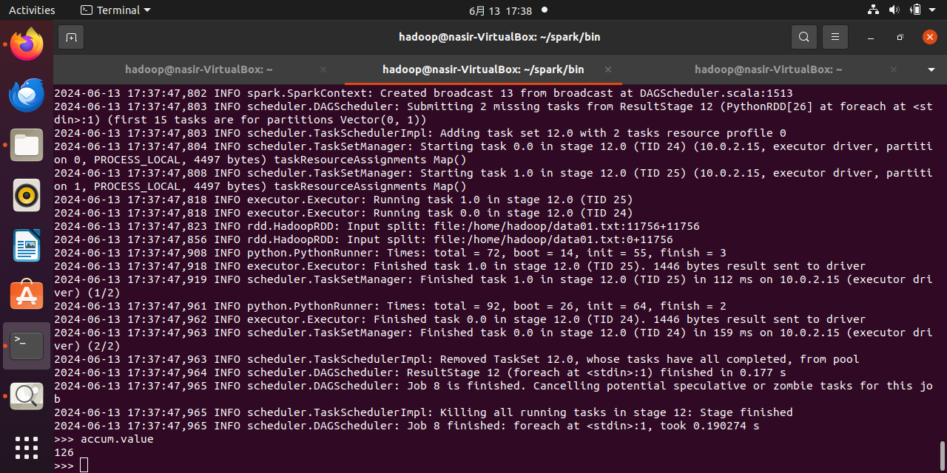

**Task 2**